**Problem to Solve:**

-Have ingredients for a meal and don’t know what to make.

**solution:**

-This app will let you know what recipes are available for the ingredients you have

-This app will also give nutritional information per ingredient

**Method:**

1. Nav bar for title and any additional functionality we may need
2. Text form field for User input on the left pane
3. Main Div will have Recipes and Nutrtion
   * + spoonacular API will allow for this recipe results from user inputted ingredients
     + nutritionix API will allow for nutritional information.
4. Charts.JS will be used to give a macro breakdown on the right pane

**UI:**

Bootstrap will be used for the main framework to hold everything

* + - Bootstrap will enable mobile compatibility as well

New stuff:

charts.js to visually show nutritional information.

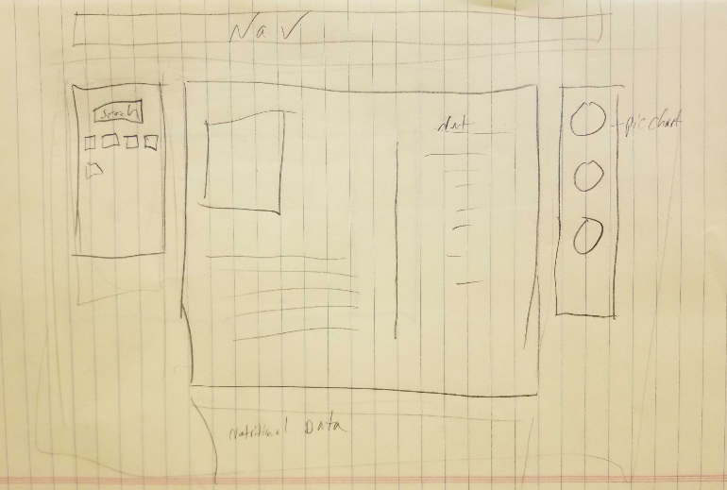

**Tasks:**

-UI with Boostrap

-Spoonacular API

- Nutritionix

-Charts.JS

-Collaborative merge of tasks